**SDRconnect Unleashed:**

**Revolutionizing Radio Control Software!**

[*www.learnminds.co.za*](http://www.learnminds.co.za)

*Author: Marius Lubbe ZS1ML*

Hey there, fellow enthusiast and experimenter! Let's dive into the SDRPlay [SDRconnect software](https://www.sdrplay.com/sdrconnect/), which has been creating quite a buzz in the software-defined radio (SDR) community.

First Impressions

So, SDRPlay released SDRconnect Preview 1 on August 10, 2023, and, let me tell you, it's been an exciting journey since then. It's a real treat for tech enthusiasts like us who love to tinker with radio gear. The software supports a range of operating systems - Windows, Linux, and MacOS - and all current [SDRplay RSP devices](https://www.sdrplay.com/rsp1a/), including the cool diversity reception on RSPduo​​.The latest iteration is 30 November 2023, and is available, as I write this. It also has some very useful [new videos guides](https://www.sdrplay.com/sdrconnect-video-guides2/) to the new features in the latest version. A lot to wrap your head around but beautifully presented.

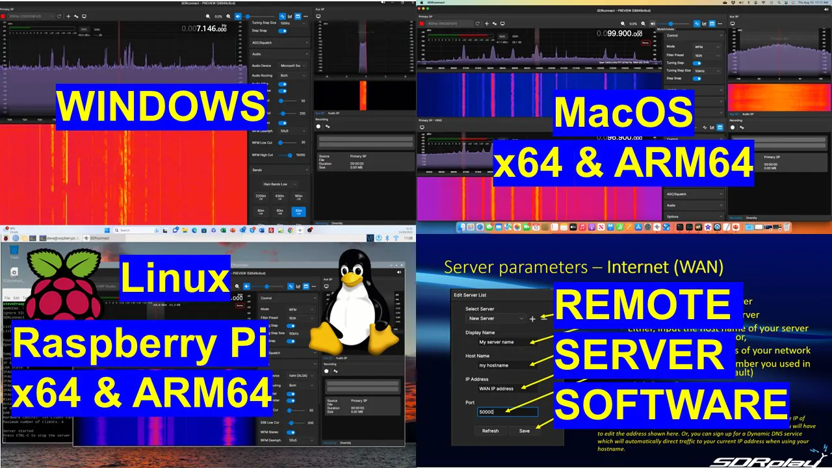

Installation and Setup

Getting SDRconnect up and running was a breeze. I mean, it's pretty straightforward and quick, and you don't even need to dig into the manual to get started. It's like they've made it foolproof for even the most casual user.

The Techy Bits

SDRconnect has this cross-platform real-time control system, which, frankly, is no small feat. They've managed to create a seamless interface with various hardware layers for real-time performance, which is quite impressive. It's built on the [Model-View-Controller (MVC) pattern](https://developer.mozilla.org/en-US/docs/Web/HTTP/Headers/Sec-Fetch-Site), making it a solid testbed for this architecture across different OS. This means it's set up to expand its features down the line, like adding memory, scanning, and plug-ins​​.

Using the Software

Now, let's talk about using SDRconnect. The user interface is pretty neat and comes with these new docking mechanisms. This allows for adding more windows and controls as the software develops. The remote server feature works pretty well, although setting it up can be a bit tricky due to its command line configuration. But once you get it up and running, the performance on your local network is quite impressive. However, I should note that diversity reception isn't available in this mode yet.

I've tried out SDRconnect on Windows 10 and Linux, both locally and remotely, and it's been smooth sailing. Everything runs as you'd expect, which speaks volumes about its stability and performance​​.

Features and Capabilities

SDRconnect is still in the early stages, but it already packs some solid features. There's direct frequency input, support for additional bands, 64-bit IQ recording, asymmetrical filter editing, and notch filters in the Aux spectrum. Plus, it supports multiple VRXs with basic radio controls and has a calibrated power meter, S-meter, SNR measurement, and band framing. For the RSPdx users, there's HDR mode support, and RSPduo users get manual diversity control. The headless server command line options are a nice touch for more advanced users​​.

Compatibility and Future Developments

It's important to note that SDRconnect is a 64-bit application, so it won't work on 32-bit systems. For plugin lovers, SDRuno plugins don't work with SDRconnect yet, but there's a plan to port them over as modules. This should open up more possibilities for customization and functionality​​.

Wrapping Up

In a nutshell, SDRconnect from SDRPlay is shaping up to be a robust and versatile tool for the SDR community. It's user-friendly for beginners but doesn't skimp on the features that more experienced users look for. The fact that it's designed to evolve and expand its capabilities is really exciting. I'm definitely looking forward to seeing how it grows and improves with future updates!